進行系統性回顧之文獻搜尋紀錄表
Literature Search for Conducting Systematic Review: Documentation Form
- 研究問題Question
Question:
Population
Intervention
Comparison
Outcome
Type of Question/
Publication Type

- 檢索詞Search Terms
 | 中文同義字  Chinese Synonyms | 英文同義字  English Synonyms | 控制詞彙 Emtree / MeSH  Controlled Vocabulary
P
I
C
O
其他限制Limits: (除非特殊原因，否則避免語言與年代等限制) Avoid using languages and years as limitations unless under exceptional circumstances.
註1: 控制詞彙縮格表示廣狹義關係，使用廣義字檢索預設會包含狹義字。其他資料庫之控制詞彙請表達在第4項搜尋策略即可。

- 搜尋資料庫 Searched Databases
資料庫  Database | 新文通知  Alert | 搜尋日期  Date searched | 書目紀錄筆數Citations
 |  |  | 搜尋結果  Records identified through database searching | 排除重複後 /  篇名摘要待篩  Records after duplicates removed / Records screened |  | 全文待篩  Full-text articles assessed for eligibility |  | 納入質性綜述  Studies included in qualitative synthesis |  | 納入統合分析Studies included in quantitative synthesis
- Embase |  |  |  | included: |  | included: |  | included: |  | included:
- MEDLINE
- CENTRAL
additional sources | - | -
文獻篩選流程PRISMA flow diagram: |  |  | included:
 |  |  | de-duplicates: |  | excluded: |  | excluded:  說明排除理由 |  | excluded:  說明排除理由
註2: 篩選流程自去除重複後，每階段都需要兩位評讀者Reviewers獨立進行再彙整共識，必要時由第三位裁決 After deduplication,
every screening stage requires two reviewers to check the articles independently, the files will be sent to a third reviewer if necessary.
註3: 重複排除與篩選流程管理，可利用相關軟體，例如EndNote（for SR教材下載後須解壓縮）You can use EndNote software to manage deduplication and screening process.
註4: 請保存自資料庫輸出之各書目紀錄原始檔案，可供未來更新搜尋比對新增書目使用。Please keep all the original bibliography files exported from databases for future use.

- 搜尋策略Search Strategy（投稿時附上此項為Appendix）This table should be included as an appendix to journal article.
資料庫 Database | # | 搜尋語法  Search syntax | 結果筆數Citations found
Embase | 1
 | 2
 | 3
 | 4
 | 5
 | 6
 | 7
 | 8
 | 9
 | 10
MEDLINE | 1
 | 2
 | 3
 | 4
 | 5
 | 6
 | 7
 | 8
 | 9
 | 10
CENTRAL | 1
 | 2
 | 3
 | 4
 | 5
 | 6
 | 7
 | 8
 | 9
 | 10

- 附註Notes (包含檢索畫面截圖Include screenshot of search results.)

附錄1: 檢索語法對照表 Cross table of search syntax for different databases
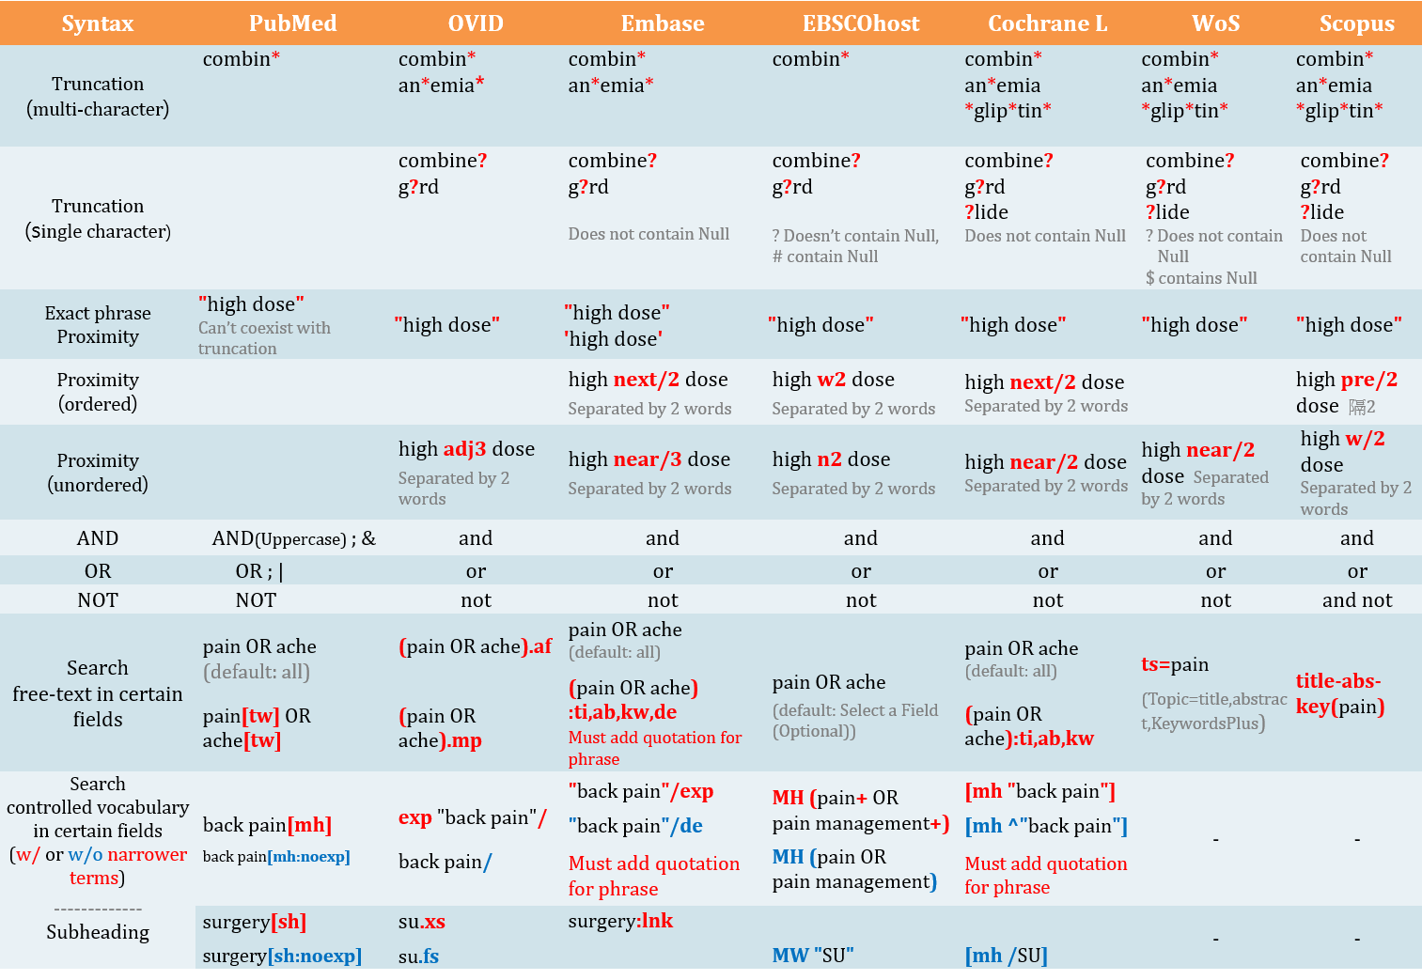
附錄Appendix2-1: RCT Filters（CENTRAL收錄即RCT為主，無須套用Filter。不同研究問題類型/研究設計、資料庫/平台，套用的Filters各異，如有需要請洽詢）
Note: CENTRAL in Cochrane Library only includes RCTs, therefore do not need to use filters. Each database or different type of study questions/design requires specific filter.
If you are looking for the filters of other study design, please contact Kun-Yen Medical Library.
Embase [Elsevier] | Medline [Ovid] | Medline [PubMed] | CINAHL [EBSCOhost] | PsycInfo [EBSCOhost] | Web of Science
Lefebvre et al (UK Cochrane):  ('crossover procedure':de OR 'double-blind procedure':de OR 'randomized controlled trial':de OR 'single-blind procedure':de OR (random* OR factorial* OR crossover* OR cross NEXT/1 over* OR placebo* OR doubl* NEAR/1 blind* OR singl* NEAR/1 blind* OR assign* OR allocat* OR volunteer*):de,ab,ti)  Lefebvre C, Manheimer E, Glanville J. Chapter 6: Searching for studies. In: Higgins J, Green S (editors). Cochrane Handbook for Systematic Reviews of Interventions. Version 5.1.0 (updated March 2011). The Cochrane Collaboration, 2011. Available from www.cochrane-handbook.org  Wong et al:  sensitivity maximizing strategy:  (random*:ab,ti OR (clinical NEXT/1 trial*):de,ab,ti OR 'health care quality'/exp)  specificity maximizing strategy:  ((double NEXT/1 blind*):de,ab,ti OR placebo*:ab,ti OR blind*:ab,ti)  best optimization of sensitivity and specificity:  (random*:ab,ti OR placebo*:de,ab,ti OR (double NEXT/1 blind*):ab,ti)  Wong SS, Wilczynski NL, Haynes RB. Developing optimal search strategies for detecting clinically sound treatment studies in EMBASE. Journal of the Medical Library Association : JMLA. 2006 Jan;94(1):41-7  SIGN: http://www.sign.ac.uk/methodology/filters.htm  ('clinical trial'/de OR 'randomized controlled trial'/de OR 'randomization'/de OR 'single blind procedure'/de OR 'double blind procedure'/de OR 'crossover procedure'/de OR 'placebo'/de OR 'prospective study'/de OR 'randomi?ed controlled' NEXT/1 trial* OR rct OR 'randomly allocated' OR 'allocated randomly' OR 'random allocation' OR allocated NEAR/2 random OR single NEXT/1 blind* OR double NEXT/1 blind* OR (treble OR triple) NEAR/1 blind* OR placebo*)  The Scottish Intercollegiate Guidelines Network (SIGN) Search Filters Web Page. Available from: http://www.sign.ac.uk/methodology/filters.html | Cochrane  http://handbook.cochrane.org/  sensitivity-maximizing:  (randomized controlled trial.pt. or controlled clinical trial.pt. or randomi*ed.ab. or placebo.ab. or drug therapy.fs. or randomly.ab. or trial.ab. or groups.ab. not (exp animals/ not humans.sh.)) | Cochrane  http://handbook.cochrane.org/  sensitivity-maximizing:  (randomized controlled trial[pt] OR controlled clinical trial[pt] OR randomized[tiab] OR randomised[tiab] OR placebo[tiab] OR drug therapy[sh] OR randomly[tiab] OR trial[tiab] OR groups[tiab] NOT (animals [mh] NOT humans [mh])) | Mark Clowes:  http://www.sign.ac.uk/search-filters.html  (MH "Clinical Trials+") or (PT Clinical trial) or (TX clinic* n1 trial*) or TX ( (singl* n1 blind*) or (singl* n1 mask*) ) or TX ( (doubl* n1 blind*) or (doubl* n1 mask*) ) or TX ( (tripl* n1 blind*) or (tripl* n1 mask*) ) or TX ( (trebl* n1 blind*) or (trebl* n1 mask*) ) or (TX randomi* control* trial*) or (MH "Random Assignment") or (TX random* allocat*) or (TX placebo*) or (MH "Placebos") or (MH "Quantitative Studies") or (TX allocat* random*) | Watson et al:  DE "Treatment Effectiveness Evaluation" OR DE "Treatment Outcomes" OR DE "Psychotherapeutic Outcomes" OR DE "Placebo" OR DE "Followup Studies" OR placebo* OR random* OR "comparative stud*" OR (clinical N3 trial*) OR (research N3 design) OR (evaluat* N3 stud*) OR (prospectiv* N3 stud*) OR (singl* OR doubl* OR trebl* OR tripl*) N3 (blind* OR mask*)  Watson RJ, Richardson PH. Identifying randomized controlled trials of cognitive therapy for depression: comparing the efficiency of Embase, Medline and PsycINFO bibliographic databases. Br J Med Psychol. 1999 Dec;72 ( Pt 4):535-42  Eady et al:  Best sensitivity:  EBSCOhost介面無法直接以單一符號表示包含狹義詞，要逐一列出數量太龐大，不推薦使用此語法  Best optimization of sensitivity and specificity:  "double-blind" OR "random* assigned" OR control  Eady AM, Wilczynski NL, Haynes RB. PsycINFO search strategies identified methodologically sound therapy studies and review articles for use by clinicians and researchers. Journal of Clinical Epidemiology. 2008 Jan;61(1):34-40  此參考Cochrane推薦之ProQuest平台語法，將其修改為EBSCOhost平台語法 | University of Alberta Libraries:  http://guides.library.ualberta.ca/health-sciences-search-filters/study-type-filters  TS= clinical trial* OR TS=research design OR TS=comparative stud* OR TS=evaluation stud* OR TS=controlled trial* OR TS=follow-up stud* OR TS=prospective stud* OR TS=random* OR TS=placebo* OR TS=(single blind*) OR TS=(double blind*)
 | sensitivity- and precision-maximizing:  (randomized controlled trial.pt. or controlled clinical trial.pt. or randomi*ed.ab. or placebo.ab. or clinical trials as topic.sh. or randomly.ab. or trial.ti. NOT (exp animals/ not humans.sh.)) | sensitivity- and precision-maximizing:  (randomized controlled trial[pt] OR controlled clinical trial[pt] OR randomized[tiab] OR randomised[tiab] OR placebo[tiab] OR clinical trials as topic[mesh:noexp] OR randomly[tiab] OR trial[ti] NOT (animals[mh] NOT humans [mh]))
 |  |  |  |  | Scopus
 |  |  |  |  | ( TITLE-ABS-KEY (randomi*ed OR placebo OR randomly) OR TITLE (trial) )
註5: 紅字為外加，非Cochrane原始提供
附錄Appendix 2-2: Cohort Study / Case Controlled Study (不同研究問題類型/研究設計、資料庫/平台，套用的Filters各異，請謹慎，如有需要請洽詢；紅字是有異於原始Filter) Each database or different type of study questions/design requires specific filter. If you are looking for the filters of other study design, please contact Kun-Yen Medical Library.
Embase [Elsevier] | Medline [Ovid] | Medline [PubMed] | CINAHL [EBSCOhost] | PsycInfo [EBSCOhost] | Web of Science
('cohort analysis'/exp OR 'longitudinal study'/exp OR 'prospective study'/exp OR 'follow up'/exp OR cohort* OR 'case control study'/exp OR (case* NEXT/5 (control* OR crosscover OR cross-over)) OR (case NEXT/3 comparision*) OR "control group*" OR risk* OR incidence*)  Source: BMJ, http://bestpractice.bmj.com/info/toolkit/learn-ebm/study-design-search-filters/ | 1. exp cohort studies/ OR cohort*.tw OR controlled clinical trial.pt OR exp case-control studies/ OR ((case* ADJ5 (control* OR crossover OR cross-over)) OR (case ADJ3 comparision*) OR "control group*").tw OR (risk* OR incidence*).tw  2. epidemiologic methods/  3. limit 2 to yr="1966-1989"  4. 1 or 3  (黃標要改用實際產生的序號)  此Filter因為在個#2的年份要限定，故要執行5個步驟，最後把以上結果和您的PICO查詢結果用AND結合，就可以篩選出可能是這類研究設計的文章  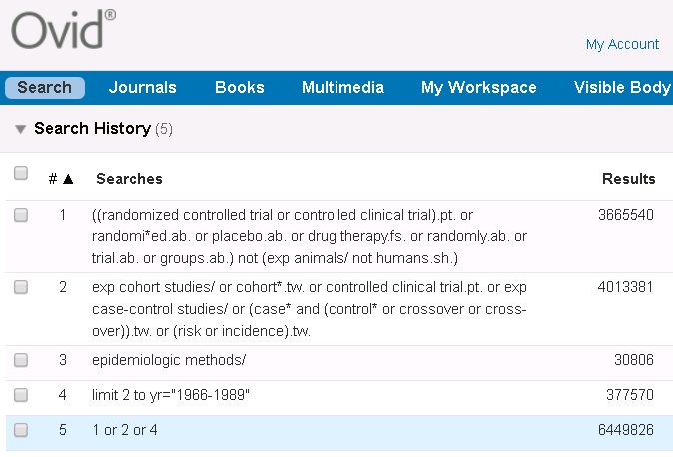  Source: modified from BMJ, http://bestpractice.bmj.com/info/toolkit/learn-ebm/study-design-search-filters/ | (cohort studies[mh] OR cohort*[tw] OR controlled clinical trial[pt] OR case-control studies[mh] OR (case*[tw] AND (control*[tw] OR crossover[tw] OR cross-over[tw] OR comparison*[tw])) "control group"[tw] OR "control groups"[tw] OR risk*[tw] OR incidence*[tw] OR (epidemiologic methods[mh:noexp] AND ("1966"[dp]:"1989"[dp])))  Source: modified from BMJ, http://bestpractice.bmj.com/info/toolkit/learn-ebm/study-design-search-filters/ | (MH "Prospective studies" OR MH "Case Control Studies+" OR MH "Correlational Studies" OR MH "Nonconcurrent Prospective Studies" OR (cohort w1 (study or studies)) OR (observational W1 (study OR studies)) OR (case* W4 (control* or crossover or cross-over)) OR (case N2 comparision*) OR "control group*" OR risk* OR incidence*)  Source: SIGN, http://www.sign.ac.uk/assets/search-filters-observational-studies.docx | ((cohort OR longitudinal OR prospective OR retrospective OR (MR "longitudinal study") OR (MR "prospective study") OR (MR "retrospective study") OR (case* W4 (control* OR crossover OR cross-over)) OR (case N2 comparison*) OR "control group*" OR risk* OR incidence*) NOT MR "Literature Review")  Source: modified from http://libguides.sph.uth.tmc.edu/ovid_psycinfo_filters  Methodology: MD [Ovid) = MR (EBSCO) | --

