系統性回顧研究 (SR)：更新檢索指引

- 時機：投稿前，更新上次檢索後的新增文章
- 方式：利用資料庫的「書目紀錄匯入資料庫日期」做為檢索條件，並結合既有檢索策略
(若利用「出版日期」，將可能遺漏早已出版，後續才加入資料庫的書目)
- 範例：
- 欲更新下列區間的新加入文章
2021/8/15 (初始/上次日期)～2022/4/18 (今日日期)
- PIO檢索策略總結果為 #7 = (#1 OR #2) AND (#3 OR #4) AND (#5 OR #6)
資料庫 | 搜尋語法
Embase.com  (Elsevier) | 方法一 (建議)  #7 AND [15-8-2021]/sd (指定起始日期，不指定結束日期)  方法二  #7 AND [15-08-2021]/sd NOT [19-04-2022]/sd (指定結束日期)  方法三  利用Result > Date介面，輸入下圖條件  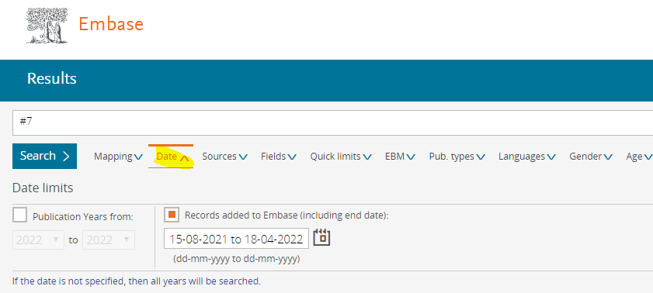
MEDLINE (Ovid) | limit 7 to dt=20210815-20220418
Cochrane Library: Trials (CENTRAL) | #7 Limits in:  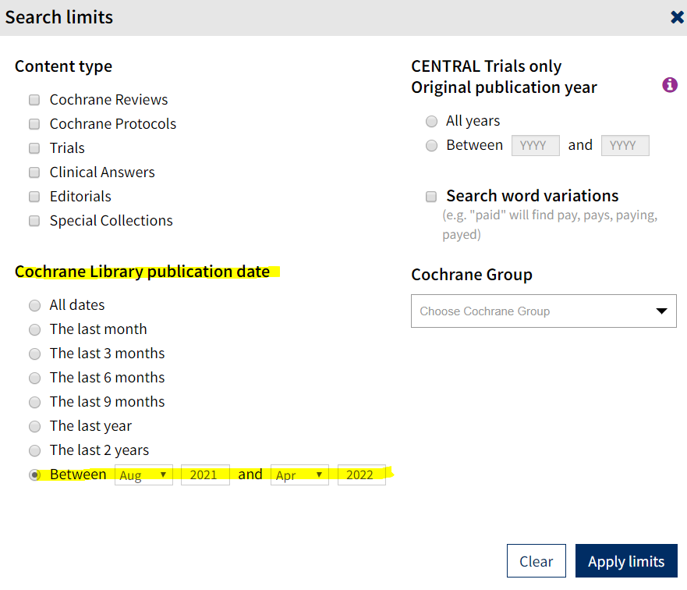
EBSCOhost  (適用於CINAHL、AgeLine等) | 方法1  S7 AND EM 20210815- (不指定結束日期，可取得至目前最新)  方法2  S7 AND EM 20210815-20220418  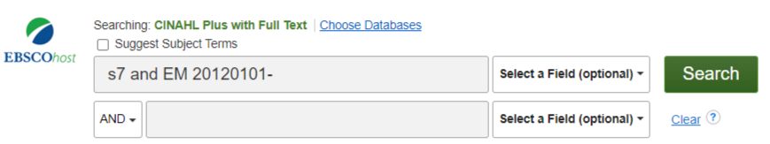
Web of Science | #7  Index date:2021-08-15 to 2022-04-18
Scopus | 方法1  - 於進階檢索，輸入：LOAD-DATE AFT 20210815 (即為#8)  - 再於組合檢索區，輸入：#7 AND #8  方法2  第一次檢索時即儲存於檢索歷史，要更新時可自動獲得新增書目

- 文獻篩選流程圖彙整方式：
(1) 首次/上次檢索: 2021/8/14
資料庫  Database | 新文通知 | 搜尋日期  Date searched | 筆數Citations
 |  |  | 搜尋結果  Records identified from | 篇名摘要待篩選  Records screened |  | 全文待獲取  Reports sought for retrieval |  | 全文待篩選  Reports assessed for eligibility |  | 納入分析 Included
- Embase | - | 2021/8/14 | 302 | included:  700 |  | included:  103 |  | included:  100 |  | Studies included in review: 10  Reports of included studies: 13
- MEDLINE (Ovid) | - | 2021/8/14 | 177
- Cochrane CENTRAL | - | 2021/8/14 | 232
- CINAHL (EBSCOhost) | - | 2021/8/14 | 117
- Scopus | - | 2021/8/14 | 237
other sources | - | -
PRISMA flow diagram: |  |  | included:  1,065
 |  |  | de-duplicates:  365 |  | excluded:  597 |  | excluded:  3 |  | excluded: 87  說明排除理由
(2) 更新檢索: 20222/4/18
- 各資料庫因為「書目紀錄匯入資料庫日期」定義不同、資料重整的問題，即有可能新舊兩次加總筆數，不等於重新檢索筆數。
- 建議可以將兩次檢索所獲得的各階段數字直接加總即可，不需計算重新檢索筆數。範例如下，綠色數字本次新增數量、紅色數字代表上次+本次數量，請用紅色數字填入PRISMA流程圖：
資料庫  Database | 新文通知 | 更新日期  Date searched | 筆數Citations
 |  |  | 搜尋結果  Records identified from | 篇名摘要待篩選  Records screened |  | 全文待獲取  Reports sought for retrieval |  | 全文待篩選  Reports assessed for eligibility |  | 納入分析 Included
- Embase | - | 2022/4/18 | 302+30 =332 | included:  700 +30  [ 1,000 ] |  | included:  103 +5  [ 108 ] |  | included:  100 +5  [ 105 ] |  | Studies included in review: 10+1  [ 11 ]  Reports of included studies: 13+1  [ 14 ]
- MEDLINE (Ovid) | - | 2022/4/18 | 177 +10 =187
- Cochrane CENTRAL | - | 2022/4/18 | 232 +10 =242
- CINAHL (EBSCOhost) | - | 2022/4/18 | 117 +10 =127
- Scopus或WOS | - | 2022/4/18 | 237 +10 =247
other sources | - | -
PRISMA flow diagram: |  |  | included:  1,065 +70  [ 1,135 ]
 |  |  | de-duplicates:  365 + 40  [ 405 ] |  | excluded:  597 + 25  [ 622 ] |  | excluded:  3 + 0  [ 3 ] |  | excluded:  87 + 4  [ 91 ]

- 內文書寫方式
(1) 用更新檢索方式：Five databases were searched for relevant randomized controlled trials (RCTs), from their inception dates to August 2021, and an updated search was conducted in April 2022.

(2) 用自動通知方式：Five databases were searched for relevant randomized controlled trials (RCTs), from their inception dates to August 2021……We also established e-mail alerts to identify newly released studies from the different databases, which fell within the scope of our review.

