進行系統性回顧之文獻搜尋紀錄表
Literature Search for Conducting Systematic Review: Documentation Form
- 研究問題Question
Question: | 對學齡童增加身體活動可以促進體重控制嗎？
Population | 學齡童
Intervention | 身體活動
Comparison
Outcome | 體重控制
Type of Question/
Publication Type

- 檢索詞Search Terms
 | 中文同義字  Chinese Synonyms | 英文同義字  English Synonyms | 控制詞彙  Controlled Vocabulary
P1 | 學校
P2 | 兒童
I | 身體活動
C
O | 體重
 | 血糖 | 練習批改:  glycemic  glycaemia  glycemic control  glycemic monitor  blood glucose  hba1c  測試鄰近字的使用:  glycated hemoglobin  glycated haemoglobin  glycosylated hemoglobin  glycosylated haemoglobin | 練習批改:  glycemic control*  glucose blood level  blood glucose level  glycosylated hemoglobin  hemoglobin A1c  Blood Glucose  Glycated Hemoglobin A
蒐集來源 |  | ☐ 控制詞彙表之同義詞清單  ☐ 控制詞彙表之狹義控制詞彙  ☐ SR: Appendices, Search Methods  ☐ 瀏覽相關文章 | ☐ 詞表查詢 > 決定控制詞彙位階 (廣/狹)  ☐ 高相關文章的控制詞彙給了甚麼  (subject, thesaurus, subject filter)  ☐ SR: Appendices, Search Methods  ☐ 若某個資料庫有特定控制詞彙，應該推想另一個資料庫也可能有對應的控制詞彙
自我檢核錯誤樣態 |  | ☐ diabetes、diabetes mellitus: 只需使用diabetes即可包含diabetes mellitus結果  ☐ gestational diabetes: 兩個單字以上組成的詞彙，必須指定其為下列三種關係之一，文章數由多到少依次如下:  gestational AND diabetes (交集)  gestational 鄰n diabetes (鄰n個單字內)  "gestational diabetes" (精確片語)  ☐ “gestational diabetes”: 不能使用上下引號，應改為直引號"gestational diabetes"  ☐ hear*: 切截太短，獲得不相關的heart，應直接列出可能字尾變化hear、hearing  ☐ routine care: 無法完整列舉相關介入，寧可不輸入 | exercise therap*: 控制詞彙不能採用切截，應原貌呈現為exercise therapy (MeSH例)

- 搜尋資料庫 Searched Databases
資料庫  Database | 新文通知  Alert | 搜尋日期  Date searched | 筆數Citations
 |  |  | 搜尋結果  Records identified from | 篇名摘要待篩選  Records screened |  | 全文待獲取  Reports sought for retrieval |  | 全文待篩選  Reports assessed for eligibility |  | 納入分析 Included
 |  |  |  | included: |  | included: |  | included: |  | Studies included in review:  Reports of included studies:
other sources | - | -
文獻篩選流程PRISMA flow diagram: |  |  | included:
 |  |  | de-duplicates: |  | excluded: |  | excluded: |  | excluded:  說明排除理由
註2: 篩選流程自去除重複後，每階段都需要兩位評讀者Reviewers獨立進行再彙整共識，必要時由第三位裁決
註3: 重複排除與篩選流程管理，可利用相關軟體，例如EndNote
註4: 請保存自資料庫輸出之各書目紀錄原始檔案，可供未來更新搜尋比對新增書目使用。

- 搜尋策略Search Strategy（投稿時附上此項為Appendix）
資料庫 Database | # | 搜尋語法  Search syntax | 結果筆數Citations found
- Academic Complete Search [EBSCOhost] | 1 | P同義字
 | 2 | P控制詞彙
 | 3 | I同義字
 | 4 | I控制詞彙
 | 5 | O同義字
 | 6 | O控制詞彙
 | 7 | (s1 OR s2) AND (s3 OR s4) AND (s5 OR s6) | All:
 | 8 | s7 AND Filter(附錄2)
- OOO  [EBSCOhost] | 1 | P同義字
 | 2 | P控制詞彙
 | 3 | I同義字
 | 4 | I控制詞彙
 | 5 | O同義字
 | 6 | O控制詞彙
 | 7 | (s1 OR s2) AND (s3 OR s4) AND (s5 OR s6) | All:
 | 8 | s7 AND Filter(附錄2)
 | 1
 | 2
 | 3
 | 4
 | 5
 | 6
 | 7 |  | All:
 | 8
Scopus  或Web of Science | 1 | 在預設文獻搜尋介面，欄位預設選定「篇名、關鍵字、摘要」分三欄輸入：  P同義字  AND  I同義字  AND  O同義字
 | 2 | 在進階介面輸入：  Filter (附錄2)
 | 3 | 在進階介面右下角輸入：  #1 AND #2

- 附註Notes (包含檢索畫面截圖)

附錄1: 檢索語法對照表
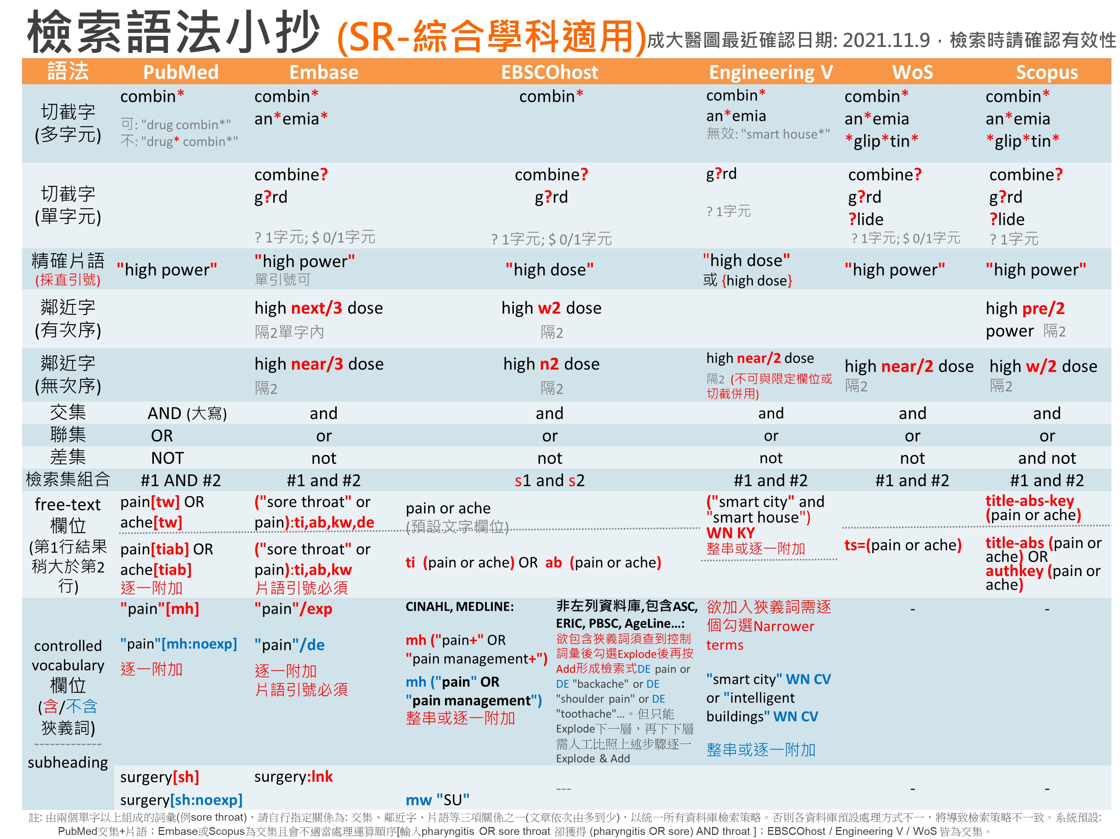
註: 修改Word不自動將一般(直)引號更改為智慧(左右)引號，請參考官網說明: Windows / Macintosh

附錄2-1: RCT Filters (CENTRAL即收錄RCT，無須套用Filter。不同問題類型/研究設計、資料庫/平台，套用的Filters各異，如有需要請洽詢；紅字是有異於原始Filter)
Embase [Elsevier] | Medline [Ovid] | Medline [PubMed] | CINAHL [EBSCOhost] | PsycInfo [EBSCOhost] | Web of Science
("randomized controlled trial"/de or "controlled clinical trial"/de or "randomization"/de or "intermethod comparison"/de or "double blind procedure"/de or "human experiment"/de OR (random* or placebo or assigned or allocated or volunteer or volunteers or (open NEXT/1 label) or ((double or single or doubly or singly) NEXT/1 (blind or blinded or blindly)) or "parallel group?" or crossover or "cross over" or ((assign* or match or matched or allocation) NEAR/5 (alternate or group? or intervention? or patient? or subject? or participant?)) OR (controlled NEAR/7 (study or design or trial))):ti,ab OR (compare or compared or comparison or trial):ti OR ((evaluated or evaluate or evaluating or assessed or assess) and (compare or compared or comparing or comparison)):ab) NOT (((random* NEXT/1 sampl* NEAR/7 ("cross section*" or questionnaire? or survey* or database?)):ti,ab not ("comparative study"/de or "controlled study"/de or "randomi?ed controlled":ti,ab or "randomly assigned":ti,ab)) OR ("Cross-sectional study"/de not ("randomized controlled trial"/de or "controlled clinical study"/de or "controlled study"/de or randomi?ed controlled:ti,ab or "control group?":ti,ab)) OR ((((case NEXT/1 control*) and random*) not randomi?ed controlled):ti,ab) OR ("Systematic review" not (trial or study)):ti OR (nonrandom* not random*):ti,ab OR "Random field*":ti,ab OR ("random cluster" NEAR/3 sampl*):ti,ab OR ((review:ab and review/it) not trial:ti) OR ("we searched":ab and (review:ti or review/it)) OR "update review":ab OR (databases NEAR/4 searched):ab OR ((rat or rats or mouse or mice or swine or porcine or murine or sheep or lambs or pigs or piglets or rabbit or rabbits or cat or cats or dog or dogs or cattle or bovine or monkey or monkeys or trout or marmoset?):ti and "animal experiment"/de) OR ("animal experiment"/de not ("human experiment"/de or "human"/de)))  Filter Source: Box 3.e, Technical Supplement to Chapter 4: Searching for and Selecting Studies. Cochrane Handbook for Systematic Reviews of Interventions Version 6. (Syntax Translated from Ovid Embase to Elsevier Embase.com.) | sensitivity-maximizing (優先採用):  (randomized controlled trial.pt. or controlled clinical trial.pt. or randomi*ed.ab. or placebo.ab. or drug therapy.fs. or randomly.ab. or trial.ab. or groups.ab. not (exp animals/ not humans.sh.))  Filter Source: Box 3.c, Technical Supplement to Chapter 4: Searching for and Selecting Studies. Cochrane Handbook for Systematic Reviews of Interventions Version 6. (Add: randomised.ab) | sensitivity-maximizing(優先採用):  (randomized controlled trial[pt] OR controlled clinical trial[pt] OR randomized[tiab] OR randomised[tiab] OR placebo[tiab] OR drug therapy[sh] OR randomly[tiab] OR trial[tiab] OR groups[tiab] NOT (animals [mh] NOT humans [mh]))  Filter Source: Box 3.a, Technical Supplement to Chapter 4: Searching for and Selecting Studies. Cochrane Handbook for Systematic Reviews of Interventions Version 6. (Add: randomized[tiab]) | (MH ("randomized controlled trials" OR "double‐blind studies" OR "single‐blind studies" OR "random assignment" OR "pretest‐posttest design" OR "cluster sample") OR TI (randomised OR randomized) OR AB (random*) OR TI (trial) OR (MH (sample size) AND AB (assigned OR allocated OR control)) OR MH (placebos) OR PT (randomized controlled trial) OR AB (control W5 group) OR MH ("crossover design" OR "comparative studies") OR AB (cluster W3 RCT)) NOT ((MH ("animals+" OR "animal studies") OR TI (animal model*)) NOT MH (human))  Filter Source: Box 3.f., Technical Supplement to Chapter 4: Searching for and Selecting Studies. Cochrane Handbook for Systematic Reviews of Interventions Version 6. | Watson et al:  DE "Treatment Effectiveness Evaluation" OR DE "Treatment Outcomes" OR DE "Psychotherapeutic Outcomes" OR DE "Placebo" OR DE "Followup Studies" OR placebo* OR random* OR "comparative stud*" OR (clinical N3 trial*) OR (research N3 design) OR (evaluat* N3 stud*) OR (prospectiv* N3 stud*) OR (singl* OR doubl* OR trebl* OR tripl*) N3 (blind* OR mask*)  Filter Source: Watson RJ, Richardson PH. Identifying randomized controlled trials of cognitive therapy for depression: comparing the efficiency of Embase, Medline and PsycINFO bibliographic databases. Br J Med Psychol. 1999 Dec;72 ( Pt 4):535-42.  Eady et al:  Best sensitivity: EBSCOhost介面無法直接以單一符號表示包含狹義詞，要逐一列出數量太龐大，不推薦使用此語法  Best optimization of sensitivity and specificity:  "double-blind" OR "random* assigned" OR control  Filter Source: Eady AM, Wilczynski NL, Haynes RB. PsycINFO search strategies identified methodologically sound therapy studies and review articles for use by clinicians and researchers. Journal of Clinical Epidemiology. 2008 Jan;61(1):34-40.  本區參考Cochrane推薦之ProQuest平台語法，將其修改為EBSCOhost平台語法 | TS= clinical trial* OR TS=research design OR TS=comparative stud* OR TS=evaluation stud* OR TS=controlled trial* OR TS=follow-up stud* OR TS=prospective stud* OR TS=random* OR TS=placebo* OR TS=(single blind*) OR TS=(double blind*)  Filter Source: American University of Beirut
附錄2-2: Observational Study (不同問題類型/研究設計、資料庫/平台，套用的Filters各異，請謹慎，如有需要請洽詢；紅字是有異於原始Filter；灰字可視研究題目刪除)
Embase [Elsevier] | Medline [Ovid] | Medline [PubMed] | CINAHL [EBSCOhost] | PsycInfo [EBSCOhost] | Web of Science
('epidemiology'/de OR 'case control study'/exp OR 'cohort analysis'/de OR 'cross-sectional study'/de  'follow up'/de OR 'longitudinal study'/de OR 'retrospective study'/de OR 'prospective study'/de OR 'observational study'/de OR 'correlational study'/de OR (epidemiologic OR 'case control' OR 'case referent' OR 'case stud*' OR 'case series' OR cohort* OR 'cross section*' OR crosssection* OR crossection* OR 'follow up' OR longitudinal OR retrospective* OR prospective* OR observational OR 'adverse effect$' OR 'controlled before and aKer' OR 'Interrupted time series' OR correlational OR 'ecological stud*' OR 'descriptive stud*'):ti,ab,kw)  Source: modified from Cochrane, https://www.cochrane.org/MR000041/METHOD_search-strategies-identify-observational-studies-medline-and-embase | (Epidemiologic Studies/ OR exp Case-Control Studies/ OR exp Cohort Studies/ OR Cross-Sectional Studies/ OR ((epidemiologic ADJ (study or studies)) OR "case control" OR (cohort ADJ (study or studies)) OR "cohort analy*" OR "cross section*" OR crosssection* OR crossection* OR ("follow up" ADJ (study or studies)) OR longitudinal OR retrospective* OR prospective* OR (observ* ADJ3 (study or studies)) OR "adverse effect?").ti,ab.)  Source: modified from Cochrane, https://www.cochrane.org/MR000041/METHOD_search-strategies-identify-observational-studies-medline-and-embase | (Epidemiologic Studies[mh:noexp] OR Case-Control Studies[mh] OR Cohort Studies[mh] OR Cross-Sectional Studies[mh:noexp] OR ((epidemiologic AND (study or studies)) OR "case control" OR (cohort AND (study or studies)) OR "cohort analy*" OR "cross section*" OR crosssection* OR crossection* OR ("follow up" AND (study or studies)) OR longitudinal OR retrospective* OR prospective* OR (observ* AND (study or studies)) OR "adverse effect*").ti,ab.)  Source: modified from Cochrane, https://www.cochrane.org/MR000041/METHOD_search-strategies-identify-observational-studies-medline-and-embase |  |  | (TS=((epidemiologic NEAR/0 (study or studies)) OR "case control" OR (cohort NEAR/0 (study or studies)) OR "cohort analy*" OR "cross sectional" OR ("follow up" NEAR/0 (study or studies)) OR longitudinal OR retrospective* OR prospective* OR (observ* NEAR/2 (study or studies)) OR "adverse effect$"))  Source: modified from Cochrane, https://www.cochrane.org/MR000041/METHOD_search-strategies-identify-observational-studies-medline-and-embase

附錄2-3: Cohort Study / Case Controlled Study (不同問題類型/研究設計、資料庫/平台，套用的Filters各異，請謹慎，如有需要請洽詢；紅字是有異於原始Filter)
Embase [Elsevier] | Medline [Ovid] | Medline [PubMed] | CINAHL [EBSCOhost] | PsycInfo [EBSCOhost] | Web of Science
('cohort analysis'/exp OR 'longitudinal study'/exp OR 'prospective study'/exp OR 'follow up'/exp OR cohort* OR 'case control study'/exp OR (case* NEXT/5 (control* OR crosscover OR cross-over)) OR (case NEXT/3 comparision*) OR "control group*" OR risk* OR incidence*)  Source: BMJ, http://bestpractice.bmj.com/info/toolkit/learn-ebm/study-design-search-filters/ | 1. exp cohort studies/ OR cohort*.tw OR controlled clinical trial.pt OR exp case-control studies/ OR ((case* ADJ5 (control* OR crossover OR cross-over)) OR (case ADJ3 comparision*) OR "control group*").tw OR (risk* OR incidence*).tw  2. epidemiologic methods/  3. limit 2 to yr="1966-1989"  4. 1 or 3  (黃標要改用實際產生的序號)  此Filter因為在個#2的年份要限定，故要執行5個步驟，最後把以上結果和您的PICO查詢結果用AND結合，就可以篩選出可能是這類研究設計的文章  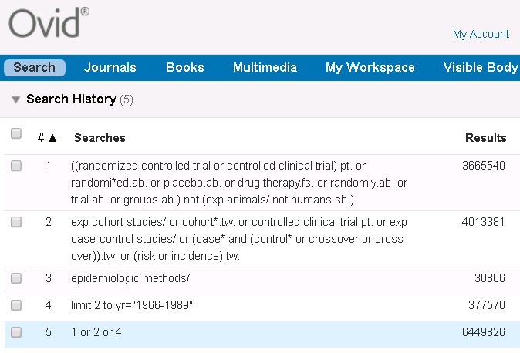  Source: modified from BMJ, http://bestpractice.bmj.com/info/toolkit/learn-ebm/study-design-search-filters/ | (cohort studies[mh] OR cohort*[tw] OR controlled clinical trial[pt] OR case-control studies[mh] OR (case*[tw] AND (control*[tw] OR crossover[tw] OR cross-over[tw] OR comparison*[tw])) "control group"[tw] OR "control groups"[tw] OR risk*[tw] OR incidence*[tw] OR (epidemiologic methods[mh:noexp] AND ("1966"[dp]:"1989"[dp])))  Source: modified from BMJ, http://bestpractice.bmj.com/info/toolkit/learn-ebm/study-design-search-filters/ | (MH "Prospective studies" OR MH "Case Control Studies+" OR MH "Correlational Studies" OR MH "Nonconcurrent Prospective Studies" OR (cohort w1 (study or studies)) OR (observational W1 (study OR studies)) OR (case* W4 (control* or crossover or cross-over)) OR (case N2 comparision*) OR "control group*" OR risk* OR incidence*)  Source: SIGN, http://www.sign.ac.uk/assets/search-filters-observational-studies.docx | ((cohort OR longitudinal OR prospective OR retrospective OR (MR "longitudinal study") OR (MR "prospective study") OR (MR "retrospective study") OR (case* W4 (control* OR crossover OR cross-over)) OR (case N2 comparison*) OR "control group*" OR risk* OR incidence*) NOT MR "Literature Review")  Source: modified from http://libguides.sph.uth.tmc.edu/ovid_psycinfo_filters  Methodology: MD [Ovid) = MR (EBSCO) | --

附錄2-4: Cross-Sectional Study (不同研究問題類型/研究設計、資料庫/平台，套用的Filters各異，請謹慎，如有需要請洽詢；紅字是有異於原始)
Embase [Elsevier] | Medline [Ovid] | Medline [PubMed] | CINAHL [EBSCOhost] | PsycInfo [EBSCOhost] | Web of Science
('cross-sectional study'/de OR 'correlational study'/de OR ('cross section*' OR crosssection* OR crossection* OR 'descriptive stud*'):ti,ab,kw)  Source: modified from Cochrane, https://www.cochrane.org/MR000041/METHOD_search-strategies-identify-observational-studies-medline-and-embase | (Cross-Sectional Studies/ OR ("cross section*" OR crosssection* OR crossection*).ti,ab.)  Source: modified from Cochrane, https://www.cochrane.org/MR000041/METHOD_search-strategies-identify-observational-studies-medline-and-embase | (Cross-Sectional Studies[mh:noexp] OR "cross section*"[tiab] OR crosssection*[tiab] OR crossection*[tiab])  Source: modified from Cochrane, http://bestpractice.bmj.com/info/toolkit/learn-ebm/study-design-search-filters/ | (MH ("Cross Sectional Studies" OR "Correlational Studies" OR "Descriptive Research") OR TI ("cross section*" OR crosssection* OR crossection* OR correlational OR "descriptive stud*" OR AB ("cross section*" OR crosssection* OR crossection* OR correlational OR "descriptive stud*"))  Source: modified from Cochrane, http://bestpractice.bmj.com/info/toolkit/learn-ebm/study-design-search-filters/ |  | (TS=("cross sectional" OR crosssection* OR crossection*))  Source: modified from Cochrane, http://bestpractice.bmj.com/info/toolkit/learn-ebm/study-design-search-filters/

