進行系統性回顧之文獻搜尋紀錄表
Literature Search for Conducting Systematic Review: Documentation Form
- 研究問題Question
Question:
Population
Intervention
Comparison
Outcome
Type of Question/
Publication Type

- 檢索詞Search Terms
 | 英文同義字  English Synonyms | 控制詞彙 EBSCOhost / ProQuest  Controlled Vocabulary
P
I
C
O
註1: 控制詞彙縮格表示廣狹義關係，使用廣義字檢索預設會包含狹義字。其他資料庫之控制詞彙請表達在第4項搜尋策略即可。

- 搜尋資料庫 Searched Databases
資料庫  Database | 新文通知  Alert | 搜尋日期  Date searched | 書目紀錄筆數Citations
 |  |  | 搜尋結果  Records identified through database searching | 排除重複後 /  篇名摘要待篩  Records after duplicates removed / Records screened |  | 全文待篩  Full-text articles assessed for eligibility |  | 納入質性綜述  Studies included in qualitative synthesis |  | 納入統合分析Studies included in quantitative synthesis
- Academic Search Complete [EBSCOhost] |  |  |  | included: |  | included: |  | included: |  | included:
- Scopus
- WOS
additional sources | -
文獻篩選流程PRISMA flow diagram: |  |  | included:
 |  |  | de-duplicates: |  | excluded: |  | excluded:  說明排除理由 |  | excluded:  說明排除理由
註2: 篩選流程自去除重複後，每階段都需要兩位評讀者Reviewers獨立進行再彙整共識，必要時由第三位裁決 After deduplication, every screening stage requires two reviewers to check the articles independently, the files will be sent to a third reviewer if necessary.
註3: 重複排除與篩選流程管理，可利用相關軟體，例如EndNote（for SR教材下載後須解壓縮）You can use EndNote software to manage deduplication and screening process.
註4: 請保存自資料庫輸出之各書目紀錄原始檔案，可供未來更新搜尋比對新增書目使用。Please keep all the original bibliography files exported from databases for future use.

- 搜尋策略Search Strategy（投稿時附上此項為Appendix）This table can be listed as an appendix to your manuscript.
資料庫 Database | # | 搜尋語法  Search syntax | 結果筆數Citations found
Academic Search Complete [EBSCOhost] | 1 | Free-text / synonyms
 | 2 | Controlled vocabulary
 | 3
 | 4
 | 5
 | 6
 | 7
Scopus  No controlled vocabulary system | 1
 | 2
 | 3
 | 4
Web of science  No controlled vocabulary system | 1
 | 2
 | 3
 | 4

- 附註Notes (包含檢索畫面截圖Include screenshot of search results.)

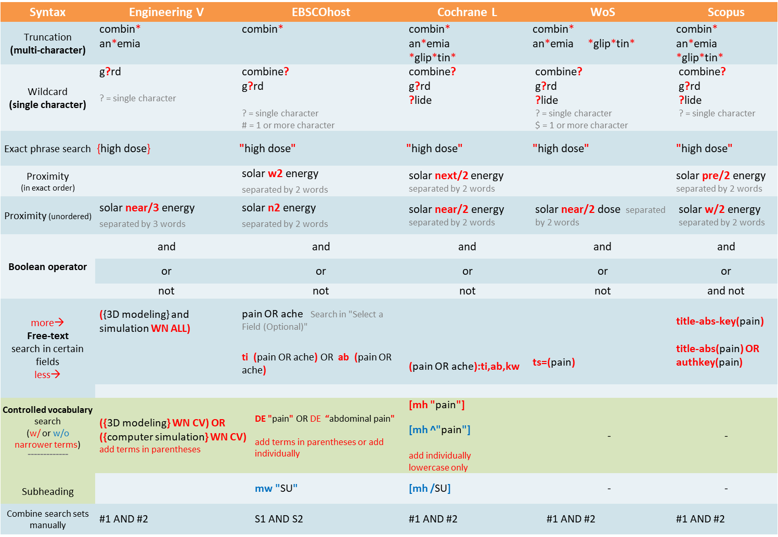
Update: 2023.02
附錄: 檢索語法對照表 Appendix : Search Syntax in Different Databases

