進行系統性回顧之文獻搜尋紀錄表
Literature Search for Conducting Systematic Review: Documentation Form
- 研究問題Question
Question:
Population
Intervention
Comparison
Outcome
Type of Question/
Publication Type

- 檢索詞Search Terms
 | 中文同義字  Chinese Synonyms | 英文同義字  English Synonyms | 控制詞彙 Emtree / MeSH  Controlled Vocabulary
P
I
C
O
其他限制Limits: (除非特殊原因，否則避免語言與年代等限制) Avoid using languages and years as limitations unless under exceptional circumstances.
註1: 控制詞彙縮格表示廣狹義關係，使用廣義字檢索預設會包含狹義字。其他資料庫之控制詞彙請表達在第4項搜尋策略即可。

- 搜尋資料庫 Searched Databases
資料庫  Database | 新文通知  Alert | 搜尋日期  Date searched | 書目紀錄筆數Citations
 |  |  | 搜尋結果  Records identified through database searching | 排除重複後 /  篇名摘要待篩  Records after duplicates removed / Records screened |  | 全文待篩  Full-text articles assessed for eligibility |  | 納入質性綜述  Studies included in qualitative synthesis |  | 納入統合分析Studies included in quantitative synthesis
- Embase |  |  |  | included: |  | included: |  | included: |  | included:
- MEDLINE
- CENTRAL
additional sources | - | -
文獻篩選流程PRISMA flow diagram: |  |  | included:
 |  |  | de-duplicates: |  | excluded: |  | excluded:  說明排除理由 |  | excluded:  說明排除理由
註2: 篩選流程自去除重複後，每階段都需要兩位評讀者Reviewers獨立進行再彙整共識，必要時由第三位裁決 After deduplication,
every screening stage requires two reviewers to check the articles independently, the files will be sent to a third reviewer if necessary.
註3: 重複排除與篩選流程管理，可利用相關軟體，例如EndNote（for SR教材下載後須解壓縮）You can use EndNote software to manage deduplication and screening process.
註4: 請保存自資料庫輸出之各書目紀錄原始檔案，可供未來更新搜尋比對新增書目使用。Please keep all the original bibliography files exported from databases for future use.

- 搜尋策略Search Strategy（投稿時附上此項為Appendix）This table should be listed as an appendix to journal article.
資料庫 Database | # | 搜尋語法  Search syntax | 結果筆數Citations found
Embase | 1
 | 2
 | 3
 | 4
 | 5
 | 6
 | 7
 | 8
 | 9
 | 10
MEDLINE  Choose OVID or PubMed | 1
 | 2
 | 3
 | 4
 | 5
 | 6
 | 7
 | 8
 | 9
 | 10
CENTRAL in Cochrane Library (RCTs only) | 1
 | 2
 | 3
 | 4
 | 5
 | 6
 | 7
 | 8
 | 9
 | 10

- 附註Notes (包含檢索畫面截圖Include screenshot of search results.)

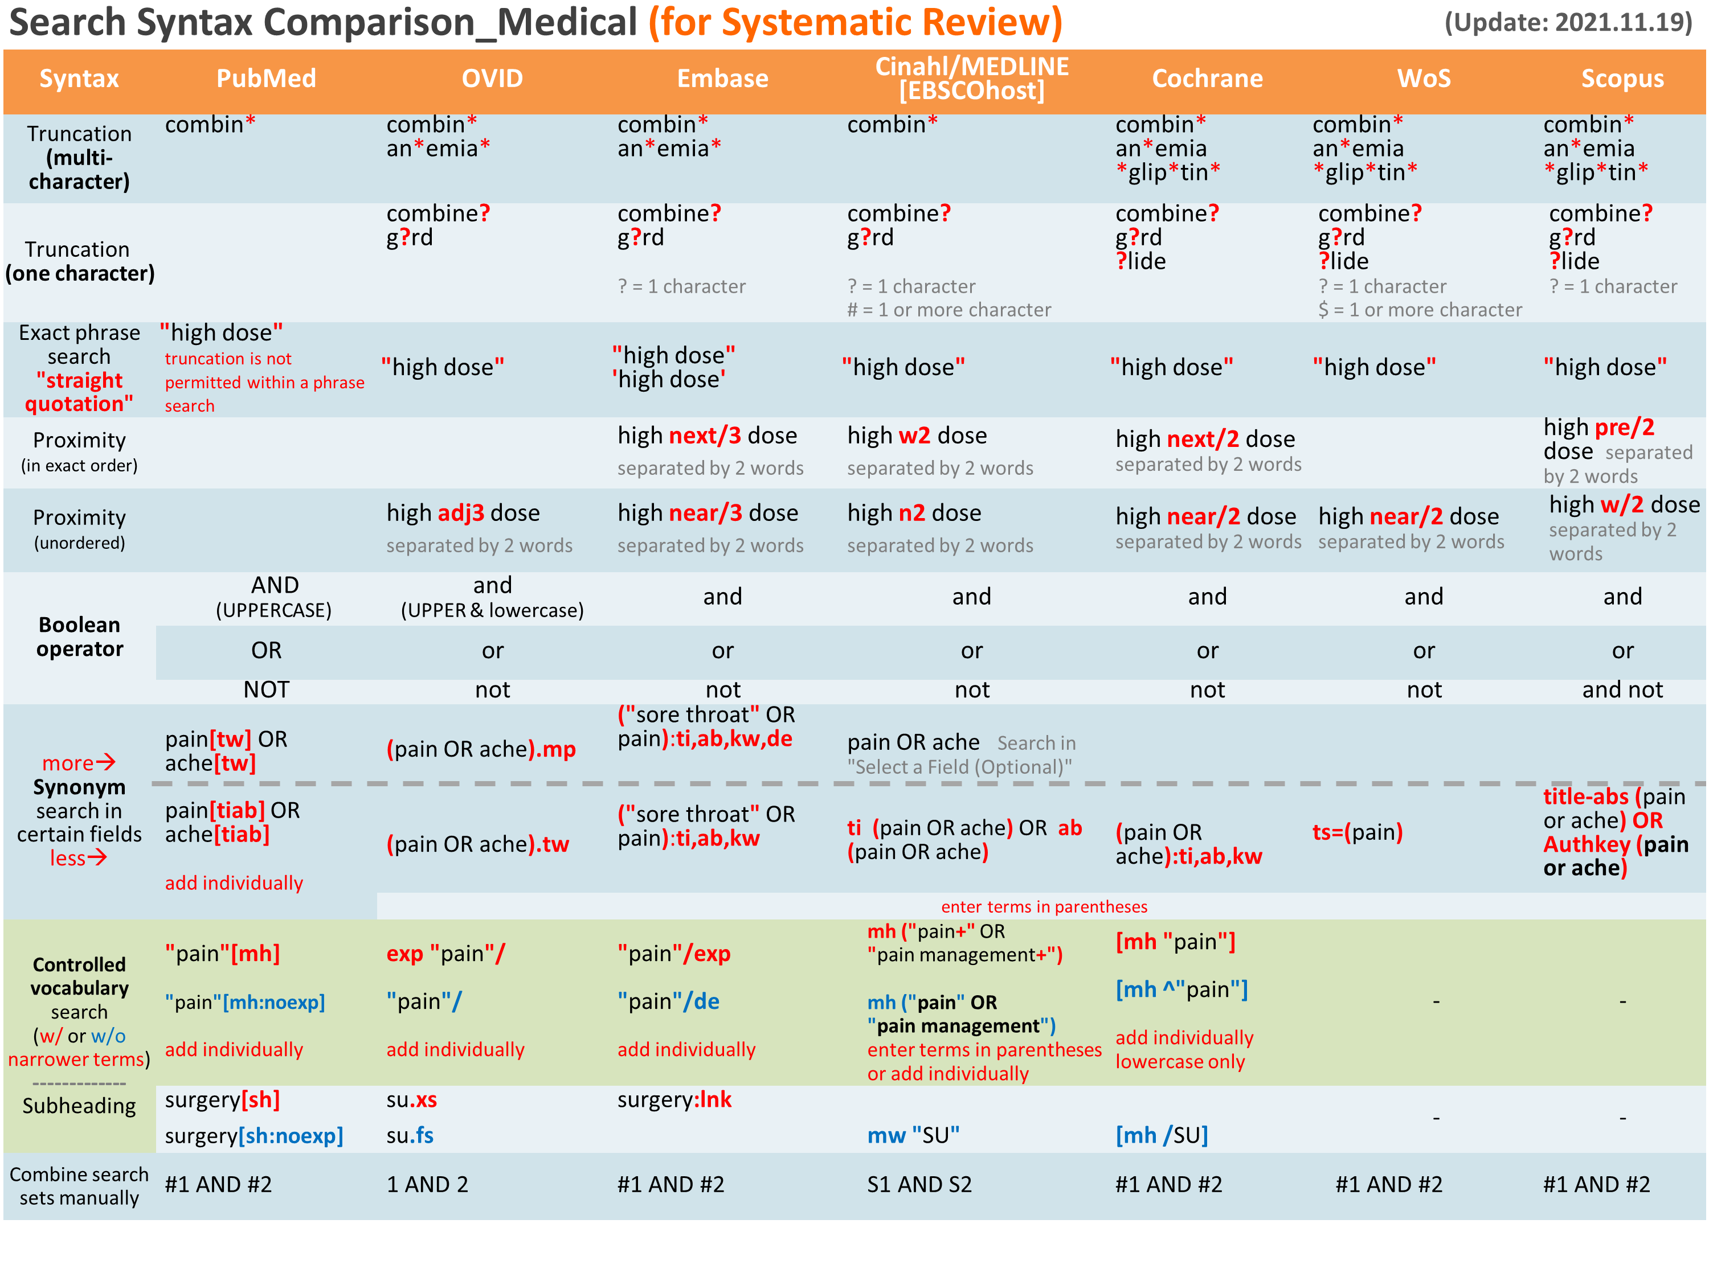
附錄1: 檢索語法對照表 Appendix 1: Search Syntax in Different Databases
附錄Appendix2-1: RCT Filters（CENTRAL收錄即RCT為主，無須套用Filter。不同研究問題類型/研究設計、資料庫/平台，套用的Filters各異，如有需要請洽詢）
Note: CENTRAL in Cochrane Library only includes RCTs, therefore do not need to use filters. Each database or different type of study questions/design requires specific filter.
If you require the filters of other study designs, please contact Kun-Yen Medical Library. Texts in red were added additionally.
Embase [Elsevier] | Medline [Ovid] | Medline [PubMed] | CINAHL [EBSCOhost] | PsycInfo [EBSCOhost] | Web of Science
("randomized controlled trial"/de or "controlled clinical trial"/de or "randomization"/de or "intermethod comparison"/de or "double blind procedure"/de or "human experiment"/de OR (random* or placebo or assigned or allocated or volunteer or volunteers or (open NEXT/1 label) or ((double or single or doubly or singly) NEXT/1 (blind or blinded or blindly)) or "parallel group?" or crossover or "cross over" or ((assign* or match or matched or allocation) NEAR/5 (alternate or group? or intervention? or patient? or subject? or participant?)) OR (controlled NEAR/7 (study or design or trial))):ti,ab OR (compare or compared or comparison or trial):ti OR ((evaluated or evaluate or evaluating or assessed or assess) and (compare or compared or comparing or comparison)):ab) NOT (((random* NEXT/1 sampl* NEAR/7 ("cross section*" or questionnaire? or survey* or database?)):ti,ab not ("comparative study"/de or "controlled study"/de or "randomi?ed controlled":ti,ab or "randomly assigned":ti,ab)) OR ("Cross-sectional study"/de not ("randomized controlled trial"/de or "controlled clinical study"/de or "controlled study"/de or randomi?ed controlled:ti,ab or "control group?":ti,ab)) OR ((((case NEXT/1 control*) and random*) not randomi?ed controlled):ti,ab) OR ("Systematic review" not (trial or study)):ti OR (nonrandom* not random*):ti,ab OR "Random field*":ti,ab OR ("random cluster" NEAR/3 sampl*):ti,ab OR ((review:ab and review/it) not trial:ti) OR ("we searched":ab and (review:ti or review/it)) OR "update review":ab OR (databases NEAR/4 searched):ab OR ((rat or rats or mouse or mice or swine or porcine or murine or sheep or lambs or pigs or piglets or rabbit or rabbits or cat or cats or dog or dogs or cattle or bovine or monkey or monkeys or trout or marmoset?):ti and "animal experiment"/de) OR ("animal experiment"/de not ("human experiment"/de or "human"/de)))  Filter Source: Box 3.e, Technical Supplement to Chapter 4: Searching for and Selecting Studies. Cochrane Handbook for Systematic Reviews of Interventions Version 6. (Syntax Translated from Ovid Embase to Elsevier Embase.com.) | sensitivity-maximizing (優先採用):  (randomized controlled trial.pt. or controlled clinical trial.pt. or randomi*ed.ab. or placebo.ab. or drug therapy.fs. or randomly.ab. or trial.ab. or groups.ab. not (exp animals/ not humans.sh.))  Filter Source: Box 3.c, Technical Supplement to Chapter 4: Searching for and Selecting Studies. Cochrane Handbook for Systematic Reviews of Interventions Version 6. (Add: randomised.ab) | sensitivity-maximizing(優先採用):  (randomized controlled trial[pt] OR controlled clinical trial[pt] OR randomized[tiab] OR randomised[tiab] OR placebo[tiab] OR drug therapy[sh] OR randomly[tiab] OR trial[tiab] OR groups[tiab] NOT (animals [mh] NOT humans [mh]))  Filter Source: Box 3.a, Technical Supplement to Chapter 4: Searching for and Selecting Studies. Cochrane Handbook for Systematic Reviews of Interventions Version 6. (Add: randomized[tiab]) | (MH ("randomized controlled trials" OR "double‐blind studies" OR "single‐blind studies" OR "random assignment" OR "pretest‐posttest design" OR "cluster sample") OR TI (randomised OR randomized) OR AB (random*) OR TI (trial) OR (MH (sample size) AND AB (assigned OR allocated OR control)) OR MH (placebos) OR PT (randomized controlled trial) OR AB (control W5 group) OR MH ("crossover design" OR "comparative studies") OR AB (cluster W3 RCT)) NOT ((MH ("animals+" OR "animal studies") OR TI (animal model*)) NOT MH (human))  Filter Source: Box 3.f., Technical Supplement to Chapter 4: Searching for and Selecting Studies. Cochrane Handbook for Systematic Reviews of Interventions Version 6. | Watson et al:  DE "Treatment Effectiveness Evaluation" OR DE "Treatment Outcomes" OR DE "Psychotherapeutic Outcomes" OR DE "Placebo" OR DE "Followup Studies" OR placebo* OR random* OR "comparative stud*" OR (clinical N3 trial*) OR (research N3 design) OR (evaluat* N3 stud*) OR (prospectiv* N3 stud*) OR (singl* OR doubl* OR trebl* OR tripl*) N3 (blind* OR mask*)  Filter Source: Watson RJ, Richardson PH. Identifying randomized controlled trials of cognitive therapy for depression: comparing the efficiency of Embase, Medline and PsycINFO bibliographic databases. Br J Med Psychol. 1999 Dec;72 ( Pt 4):535-42.  Eady et al:  Best sensitivity: EBSCOhost介面無法直接以單一符號表示包含狹義詞，要逐一列出數量太龐大，不推薦使用此語法  Best optimization of sensitivity and specificity:  "double-blind" OR "random* assigned" OR control  Filter Source: Eady AM, Wilczynski NL, Haynes RB. PsycINFO search strategies identified methodologically sound therapy studies and review articles for use by clinicians and researchers. Journal of Clinical Epidemiology. 2008 Jan;61(1):34-40.  本區參考Cochrane推薦之ProQuest平台語法，將其修改為EBSCOhost平台語法 | TS= clinical trial* OR TS=research design OR TS=comparative stud* OR TS=evaluation stud* OR TS=controlled trial* OR TS=follow-up stud* OR TS=prospective stud* OR TS=random* OR TS=placebo* OR TS=(single blind*) OR TS=(double blind*)  Filter Source: American University of Beirut
 | sensitivity- and precision-maximizing (折衷採用):  (randomized controlled trial.pt. or controlled clinical trial.pt. or randomized.ab. or randomised.ab. or placebo.ab. or clinical trials as topic.sh. or randomly.ab. or trial.ti. NOT (exp animals/ not humans.sh.))  Filter Source: Box 3.d, Technical Supplement to Chapter 4: Searching for and Selecting Studies. Cochrane Handbook for Systematic Reviews of Interventions Version 6. (Add: randomised.ab) | sensitivity- and precision-maximizing (折衷採用):  (randomized controlled trial[pt] OR controlled clinical trial[pt] OR randomized[tiab] OR randomised[tiab] OR placebo[tiab] OR clinical trials as topic[mesh:noexp] OR randomly[tiab] OR trial[ti] NOT (animals[mh] NOT humans [mh]))  Filter Source: Box 3.b, Technical Supplement to Chapter 4: Searching for and Selecting Studies. Cochrane Handbook for Systematic Reviews of Interventions Version 6. (Add: randomized[tiab])
 |  |  |  | Psychology and Behavioral Sciences Collection: PBSC (EBSCOhost) | Scopus
 |  |  |  | (DE "TREATMENT effectiveness" OR DE "TREATMENT failure" OR DE "HEALTH outcome assessment" OR DE "OUTCOME assessment of adolescent psychotherapy" OR DE "PLACEBOS" OR DE "FOLLOW-up studies (Medicine)" OR placebo* OR random* OR "comparative stud*" OR (clinical N3 trial*) OR (research N3 design) OR (evaluat* N3 stud*) OR (prospectiv* N3 stud*) OR ((singl* OR doubl* OR trebl* OR tripl*) N3 (blind* OR mask*)))  Filter Source: Identifying RCTs in PsycINFO. Search strategy, amended to ProQuest format. Cochrane Work. ((Syntax Translated from ProQuest PyscINFO to EBSCOhost PBSC) | ( INDEXTERMS ( "clinical trials" OR "clinical trials as a topic" OR "randomized controlled trial" OR "Randomized Controlled Trials as Topic" OR "controlled clinical trial" OR "Controlled Clinical Trials" OR "random allocation" OR "Double-Blind Method" OR "Single-Blind Method" OR "Cross-Over Studies" OR "Placebos" OR "multicenter study" OR "double blind procedure" OR "single blind procedure" OR "crossover procedure" OR "clinical trial" OR "controlled study" OR "randomization" OR "placebo" ) ) OR ( TITLE-ABS-KEY ( ( "clinical trials" OR "clinical trials as a topic" OR "randomized controlled trial" OR "Randomized Controlled Trials as Topic" OR "controlled clinical trial" OR "Controlled Clinical Trials as Topic" OR "random allocation" OR "randomly allocated" OR "allocated randomly" OR "Double-Blind Method" OR "Single-Blind Method" OR "Cross-Over Studies" OR "Placebos" OR "cross-over trial" OR "single blind" OR "double blind" OR "factorial design" OR "factorial trial" ) ) ) OR ( TITLE ( clinical trial OR trial OR rct* OR random* OR blind* ) )  Filter Source: This filter is built by NUS Medical Library using MESH and EMTREE terms as Index terms and Keywords. Useful to search in Scopus for RCTs.
註5: 紅字為外加，非Cochrane原始提供 texts in red were added additionally
附錄2-2: Observational Study (不同問題類型/研究設計、資料庫/平台，套用的Filters各異，請謹慎，如有需要請洽詢；紅字是有異於原始Filter；灰字可視研究題目刪除) Each database or different type of study questions/design requires specific filter.
If you are looking for the filters of other study designs, please contact Kun-Yen Medical Library. Texts in red were added additionally.
Embase [Elsevier] | Medline [Ovid] | Medline [PubMed] | CINAHL [EBSCOhost] | PsycInfo [EBSCOhost] | Web of Science
('epidemiology'/de OR 'case control study'/exp OR 'cohort analysis'/de OR 'cross-sectional study'/de OR 'follow up'/de OR 'longitudinal study'/de OR 'retrospective study'/de OR 'prospective study'/de OR 'observational study'/de OR 'correlational study'/de OR (epidemiologic OR 'case control' OR 'case referent' OR 'case stud*' OR 'case series' OR cohort* OR 'cross section*' OR crosssection* OR crossection* OR 'follow up' OR followup OR longitudinal OR retrospective* OR prospective* OR observational OR 'adverse effect$' OR 'controlled before and after' OR 'interrupted time series' OR correlational OR 'ecological stud*' OR 'descriptive stud*'):ti,ab,kw)  Filter Source: modified from Search strategies to identify observational studies in MEDLINE and Embase: Appendices. Cochrane Database of Systematic Reviews, 2019. (Syntax Translated from Ovid Embase to Elsevier Embase.com) | Epidemiologic Studies/ OR exp Case-Control Studies/ OR exp Cohort Studies/ OR Cross-Sectional Studies/ OR ((epidemiologic ADJ (study or studies)) OR case control OR (cohort ADJ (study or studies)) OR cross section$ OR crosssection$ OR crossection$ OR cohort analy$ OR (follow up ADJ (study or studies)) OR longitudinal OR retrospective$ OR prospective$ OR (observ$ ADJ3 (study or studies)) OR adverse effect?).ti,ab  Filter Source: modified from Search strategies to identify observational studies in MEDLINE and Embase: Appendices. Cochrane Database of Systematic Reviews, 2019. | (Epidemiologic Studies[mh:noexp] OR Case-Control Studies[mh] OR Cohort Studies[mh] OR Cross-Sectional Studies[mh:noexp] OR ((epidemiologic AND (study or studies)) OR "case control" OR (cohort AND (study or studies)) OR "cohort analy*" OR "cross section*" OR crosssection* OR crossection* OR ("follow up" AND (study or studies)) OR longitudinal OR retrospective* OR prospective* OR (observ* AND (study or studies)) OR "adverse effect*").ti,ab.)  Filter Source: modified from Search strategies to identify observational studies in MEDLINE and Embase: Appendices. Cochrane Database of Systematic Reviews, 2019. |  |  | (TS=((epidemiologic ADJ (study or studies)) OR "case control" OR (cohort NEAR/0 (study or studies)) OR "cohort analy*" OR "cross sectional" OR ("follow up" NEAR/0 (study or studies)) OR longitudinal OR retrospective* OR prospective* OR (observ* NEAR/2 (study or studies)) OR "adverse effect$"))  Filter Source: modified from Search strategies to identify observational studies in MEDLINE and Embase: Appendices. Cochrane Database of Systematic Reviews, 2019. (Syntax Translated from OvidMEDLINE to Web of Science)

附錄Appendix 2-3: Cohort Study / Case Controlled Study (不同研究問題類型/研究設計、資料庫/平台，套用的Filters各異，請謹慎，如有需要請洽詢；紅字是有異於原始Filter) Each database or different type of study questions/design requires specific filter. If you are looking for the filters of other study design, please contact Kun-Yen Medical Library. Texts in red were added additionally.
Embase [Elsevier] | Medline [Ovid] | Medline [PubMed] | CINAHL [EBSCOhost] | PsycInfo [EBSCOhost] | Web of Science
('cohort analysis'/exp OR 'longitudinal study'/exp OR 'prospective study'/exp OR 'follow up'/exp OR cohort* OR 'case control study'/exp OR (case* NEXT/5 (control* OR crosscover OR cross-over)) OR (case NEXT/3 comparision*) OR "control group*" OR risk* OR incidence*)  Source: BMJ, http://bestpractice.bmj.com/info/toolkit/learn-ebm/study-design-search-filters/ | 1. exp cohort studies/ OR cohort*.tw OR controlled clinical trial.pt OR exp case-control studies/ OR ((case* ADJ5 (control* OR crossover OR cross-over)) OR (case ADJ3 comparision*) OR "control group*").tw OR (risk* OR incidence*).tw  2. epidemiologic methods/  3. limit 2 to yr="1966-1989"  4. 1 or 3  (黃標要改用實際產生的序號)  此Filter因為在個#2的年份要限定，故要執行5個步驟，最後把以上結果和您的PICO查詢結果用AND結合，就可以篩選出可能是這類研究設計的文章  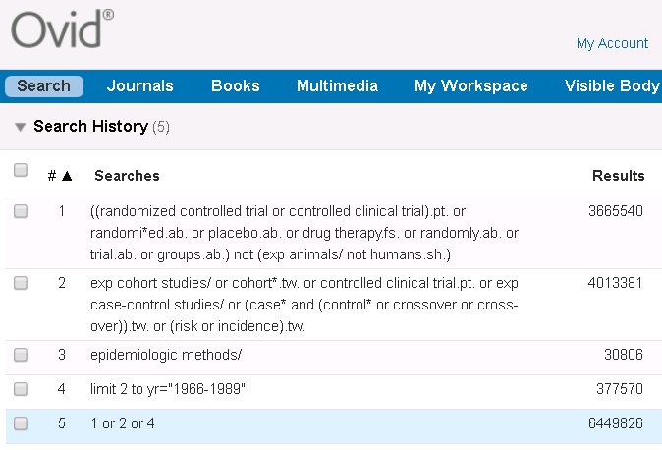  Source: modified from BMJ, http://bestpractice.bmj.com/info/toolkit/learn-ebm/study-design-search-filters/ | (cohort studies[mh] OR cohort*[tw] OR controlled clinical trial[pt] OR case-control studies[mh] OR (case*[tw] AND (control*[tw] OR crossover[tw] OR cross-over[tw] OR comparison*[tw])) "control group"[tw] OR "control groups"[tw] OR risk*[tw] OR incidence*[tw] OR (epidemiologic methods[mh:noexp] AND ("1966"[dp]:"1989"[dp])))  Source: modified from BMJ, http://bestpractice.bmj.com/info/toolkit/learn-ebm/study-design-search-filters/ | (MH "Prospective studies" OR MH "Case Control Studies+" OR MH "Correlational Studies" OR MH "Nonconcurrent Prospective Studies" OR (cohort w1 (study or studies)) OR (observational W1 (study OR studies)) OR (case* W4 (control* or crossover or cross-over)) OR (case N2 comparision*) OR "control group*" OR risk* OR incidence*)  Source: SIGN, http://www.sign.ac.uk/assets/search-filters-observational-studies.docx | ((cohort OR longitudinal OR prospective OR retrospective OR (MR "longitudinal study") OR (MR "prospective study") OR (MR "retrospective study") OR (case* W4 (control* OR crossover OR cross-over)) OR (case N2 comparison*) OR "control group*" OR risk* OR incidence*) NOT MR "Literature Review")  Source: modified from http://libguides.sph.uth.tmc.edu/ovid_psycinfo_filters  Methodology: MD [Ovid) = MR (EBSCO) | --

附錄2-4: Cross-Sectional Study (不同研究問題類型/研究設計、資料庫/平台，套用的Filters各異，請謹慎，如有需要請洽詢；紅字是有異於原始)
Each database or different type of study questions/design requires specific filter. If you are looking for the filters of other study design, please contact Kun-Yen Medical Library. Texts in red were added additionally.
Embase [Elsevier] | Medline [Ovid] | Medline [PubMed] | CINAHL [EBSCOhost] | PsycInfo [EBSCOhost] | Web of Science
('cross-sectional study'/de OR 'correlational study'/de OR ('cross section*' OR crosssection* OR crossection* OR 'descriptive stud*'):ti,ab,kw)  Source: modified from Cochrane, https://www.cochrane.org/MR000041/METHOD_search-strategies-identify-observational-studies-medline-and-embase | (Cross-Sectional Studies/ OR ("cross section*" OR crosssection* OR crossection*).ti,ab.)  Source: modified from Cochrane, https://www.cochrane.org/MR000041/METHOD_search-strategies-identify-observational-studies-medline-and-embase | (Cross-Sectional Studies[mh:noexp] OR "cross section*"[tiab] OR crosssection*[tiab] OR crossection*[tiab])  Source: modified from Cochrane, http://bestpractice.bmj.com/info/toolkit/learn-ebm/study-design-search-filters/ | (MH ("Cross Sectional Studies" OR "Correlational Studies" OR "Descriptive Research") OR TI ("cross section*" OR crosssection* OR crossection* OR correlational OR "descriptive stud*" OR AB ("cross section*" OR crosssection* OR crossection* OR correlational OR "descriptive stud*"))  Source: modified from Cochrane, http://bestpractice.bmj.com/info/toolkit/learn-ebm/study-design-search-filters/ |  | (TS=("cross sectional" OR crosssection* OR crossection*))  Source: modified from Cochrane, http://bestpractice.bmj.com/info/toolkit/learn-ebm/study-design-search-filters/

