Systematic Review: Updated Search Instruction
- Timing: Before submission, update newly added articles after the last search.
- Method: Use the "date of added to the database" as a search criterion, combined with existing search strategies. (If 'publication date' is used as a criterion, it may miss records that have already been published and are added to the database later.)
- Example:
- To update the search for newly added articles in the range:
2021/8/15 (initial/last search) ～ 2022/4/18 (at present)
- The overall result of PIO search strategy is #7 = (#1 OR #2) AND (#3 OR #4) AND (#5 OR #6)

Database | Search Syntax
Embase.com  (Elsevier) | Method 1 (Recommended):  #7 AND [15-8-2021]/sd (specified start date, no specified end date)  Method 2:  #7 AND [15-08-2021]/sd NOT [19-04-2022]/sd (specified start and end dates)  Method 3:  Use the Result > Date, input the range as shown in the figure below:  檢索日為2022/4/18，因此未設定結束日期  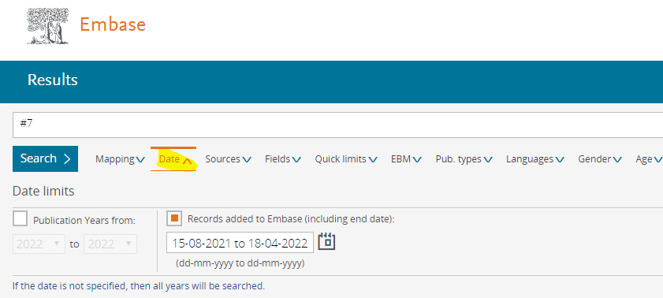
MEDLINE (Ovid) | limit 7 to dt=20210815-20220418
Cochrane Library: Trials (CENTRAL) | #7 Click "Limits" in:  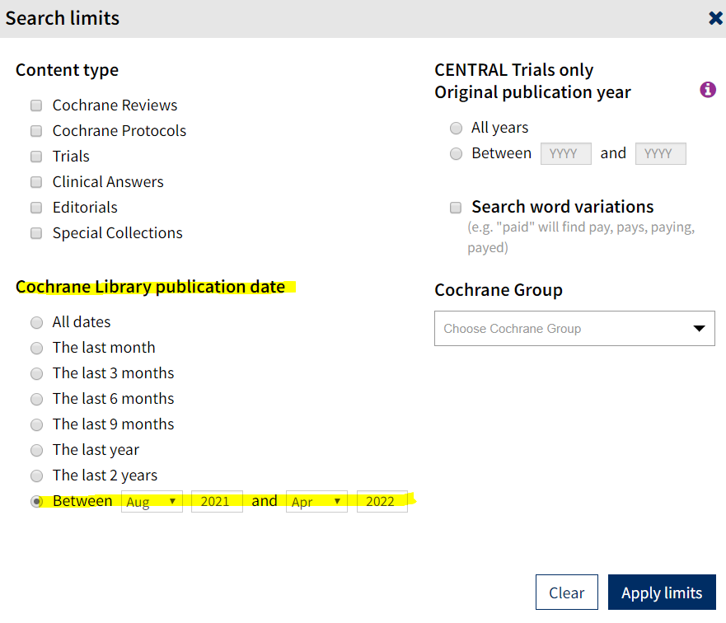
EBSCOhost  Applicable to all databases on this platform, such as CINAHL, AgeLine, etc. | Method 1 (Recommended):  S7 AND EM 20210815- (specified start date, no specified end date)  Method 2:  S7 and EM 20120101-20220418 (specified start and end dates)  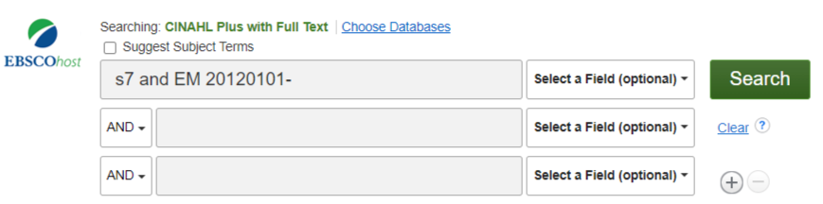
Web of Science | #7 Index date:2021-08-15 to 2022-04-18
Scopus | Method 1:  (1) Go to Advanced Search: LOAD-DATE AFT 20210815 (which is #8)  (2) Then, in the Combined Search: #7 AND #8  Method 2:  The initial search is saved in the search history, allowing for automatic retrieval of newly added bibliographies when updating.

- How to combine the PRISMA flow diagram into one:
Due to different definitions of "date of added to the database" and data reload issues in various databases, the sum of the Initial and updated search results may not equal the re-searched total number.
It is recommended to directly sum the numbers obtained at each stage of the two searches without recalculating the re-searched item count. For example:

(1) Initial/Last Search: 2021/8/14
Database | Alert | Date searched | Citations
 |  |  | Records identified from | Records screened |  | Reports sought for retrieval |  | Reports assessed for eligibility |  | Included
- Embase | - | 2021/8/14 | 302 | included:  700 |  | included:  103 |  | included:  100 |  | Studies included in review: 10  Reports of included studies: 13
- MEDLINE (Ovid) | - | 2021/8/14 | 177
- Cochrane CENTRAL | - | 2021/8/14 | 232
- CINAHL (EBSCOhost) | - | 2021/8/14 | 117
- Scopus | - | 2021/8/14 | 237
other sources | - | -
PRISMA flow diagram: |  |  | included:  1,065
 |  |  | de-duplicates:  365 |  | excluded:  597 |  | excluded:  3 |  | excluded:  87
(2) Updated Search: 2022/4/18
Green numbers represent the newly added items in this update. [Red numbers] are the sum of the initial search plus this update. For updating the PRISMA flow diagram, it is preferable to use the red numbers.
Database | Alert | Date searched | Citations
 |  |  | Records identified from | Records screened |  | Reports sought for retrieval |  | Reports assessed for eligibility |  | Included
- Embase | - | 2022/4/18 | 302 +30 =332 | included:  700 +30  [ 1,000 ] |  | included:  103 +5  [ 108 ] |  | included:  100 +5  [ 105 ] |  | Studies included in review: 10+1  [ 11 ]  Reports of included studies: 13+1  [ 14 ]
- MEDLINE (Ovid) | - | 2022/4/18 | 177 +10 =187
- Cochrane CENTRAL | - | 2022/4/18 | 232 +10 =242
- CINAHL (EBSCOhost) | - | 2022/4/18 | 117+10 =127
- Scopus | - | 2022/4/18 | 237+10 =247
other sources | - | -
PRISMA flow diagram: |  |  | included:  1,065 +70  [ 1,135 ]
 |  |  | de-duplicates:  365 + 40  [ 405 ] |  | excluded:  597 + 25  [ 622 ] |  | excluded:  3 + 0  [ 3 ] |  | excluded:  87 + 4  [ 91 ]

- Writing Examples
(1) Five databases were searched for relevant randomized controlled trials (RCTs), from their inception dates to August 2021, and an updated search was conducted in April 2022.

(2) Five databases were searched for relevant randomized controlled trials (RCTs), from their inception dates to August 2021……We also established e-mail alerts to identify newly released studies from the different databases, which fell within the scope of our review.

